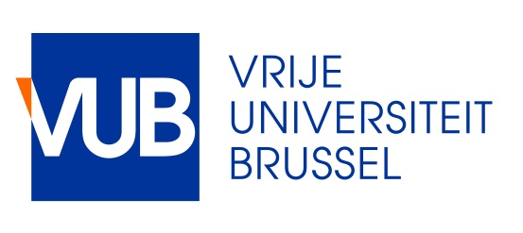
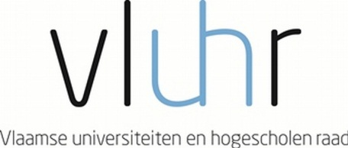

Master Mind Scholarships
Fellowship Programme for Excellent Students
Vrije Universiteit Brussel
Academic year 2017 – 2018

The Government of Flanders awards up to 45 scholarships to outstanding Master students. The programme aims to promote the internationalisation of the Flemish Higher Education, as stated in the Action Plan for Student Mobility, Brains on the Move (September 2013).

The Vrije Universiteit Brussel applies on behalf of the student.

General eligibility requirements

- The applicant applies online to take up an Initial Master degree programme at the Vrije Universiteit Brussel (VUB) http://www.vub.ac.be/en/studying-at-the-vub/how-to-enroll . A copy of the admission letter issued by the Student Administration Center of the Vrije Universiteit Brussel should be enclosed with the application file for a Master Mind scholarship.
- The applicant meets all academic entrance criteria, including relevant language requirements, for entering the Initial Master programme in question offered by the VUB and he/she should have a high standard of academic performance.
- All nationalities can apply. The previous degree obtained should be from a higher education institution located outside Flanders.
- Students who are already enrolled in a Flemish higher education institution cannot apply.

Modalities

- The duration of mobility is minimum 1 academic year and maximum the full duration of the master programme. If the student obtains less than 45 ECTS in the first year, then he/she loses the scholarship in the second year.
- The incoming student is awarded a scholarship of maximum €7.500,- per academic year.
- The Vrije Universiteit Brussel will ask the applicant for the lowest tuition fee rate. This tuition fee has to be paid per year of enrolment. For your information: for the academic year 2017-2018 this tuition fee equals 106,90 euro.
- The Vrije Universiteit Brussel submits the application, on behalf of the student. If a scholarship is awarded to a student, the scholarship can be cancelled if the student is not accepted by the Vrije Universiteit Brussel on basis of academic grounds.
- The program holds for all study areas. However some interuniversity Master programmes are excluded for a Master Mind scholarship.
- There are a number of scholarships reserved for students from certain countries: Japan (3), Mexico (3), USA (5). If these numbers of scholarships are not taken up, they will be distributed among the other candidates.
- Information about the Initial Master programmes taught at the Vrije Universiteit Brussel can be found at http://www.vub.ac.be/en/study/masters.
- Information about the language requirements can be found at http://www.vub.ac.be/en/studying-at-the-vub/language-requirements

Application

The application needs to be submitted to the Vrije Universiteit Brussel – International Relations and Mobility Office the latest on 13 April 2017.

Timing
- Student should apply online to take up a Master degree programme at the Vrije Universiteit Brussel. (http://www.vub.ac.be/en/studying-at-the-vub/how-to-enroll). A copy of the admission letter issued by the Student Administration Center has to be enclosed with the application for the scholarship.
- Deadline for applying for a Master Mind scholarship: 13 April 2017.
- Nominations of students by the Vrije Universiteit Brussel: 24 April 2017
- Upload of documents by students: 30 April 2017
- Selection: May 2017 (A Flemish selection committee, in cooperation with the Flemish Department of Education and Training, awards the scholarships)
- Announcement of selection results: June 2017
- Start of mobility: September 2017, for the academic year 2017-2018

Should you have questions about the scholarship programme, you can contact Hilde.De.Haseleer@vub.ac.be

